Signals: -
Whenever we saved the data to the database, there may be require some processing of data before just saving and after just saving the data. This we can easily achieved by using Django Signals. This signals works on the concept of senders and receivers. Signals are used to perform any action on modifcations of model instances. We can define a function which is called a receiver function and it is called when senders sends the signal to that particular receivers function. There are three types of signals;

1. pre_save/post_save : These signal works before or after the method save().
2. pre_delete/post_delete : These signal works before or after the method delete().
3. pre_init/post_init : These signals works before or after instantiating a model. That is before or after __init__ method.

Model Manager: -
It is the interface through which database query operations are provided to the Django models. At least one manager exists for every models in a django application. By default django adds a manager with the name objects to every django model class. We can change it’s name with the help of this syntax;
manager_name = models.Manager()

Model Relationships: -
Django provides three types of database relationships;
1. One to one
2. Many to one
3. Many to Many

One to One: -
It is a relationship where record in one table is associated with exactly one record in another table. To define one to one relationship we used OneToOneField.
Syntax:
OneToOneField(to,on_delete)
to => the class to which the model is related

Many to One: -
One or more row of one table are linked with only one row of other table. Let us take example of instagram, one user can post many post but one post is associated with single user. This makes many to one relation. To define many to one relationship we used foreignKey.

Many to Many: -
One or more row of one table linked with one or more row of another tables. To define many to many relationship, we used ManyToManyField.

Django Intro:-
It is free, open source, python based high level web framework. It follows the MVT pattern.

Django Project Directory structure:-

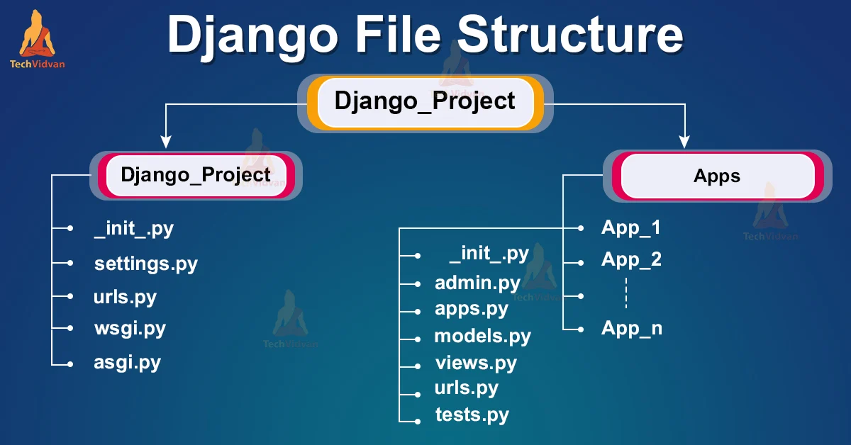
1. __init__.py ==> The folder which contain the __init__.py file is considered as python package.
2. wsgi.py ==> (Web Server Gateway Interface)
It is a specification that describes how a web server communicates with web application. WSGI provides a standard for synchronous python apps.

3. asgi.py ==> (Asynchronous Server Gateway interface)
It is a successor to WSGI. ASGI provides standard for both asynchronous and synchronous apps.

4. settings.py ==> contains all informations and data about project settings.

5. urls.py ==> It contains informations of urls attached with the applications.

6. Manage.py ==> This file is used as a command-line utility for our projects. We will use this file for debugging, deploying, and running our web applications.

URL Dispatcher:-
In order to design urls for our app, we need to create python module name urls.py. This module contains purely python code and it maps between url path and view functions.

Extends tag:-
this tag is used to inherit the templates. It has no end tag. It must be the first tag in the specific template, otherwise it will not work.

Block tag:-
This tag is used to overide the specific part of the template.
{% block blockname %}
..........
..........
{% endblock blockname %}
=> We can’t multiple tags with the same name.
=> If we need content of the block from parent template we used {{block.super}}

Include tag:-
This tag loads the template and renders it with current context. This is a way to include other template into current template.
Syntax:
{% include “templatename.html” %}
=> we can pass additional context to the template using “with” keyword.
{% include “templatename.html” with p=”php” %}

Widget:-
It represents how our html elements looks like. The widget handles the extraction of data from a GET or POST dictionary.

What is CSRF (cross site request forgery):-
Let us suppose we have just logged in into our online banking application which has no csrf protection. When we are logged in the cookies which are used for authentication is stored on our browser. Then we visit a site which looks exactly similar to our online bank application designed by malicious attacker, and it contains a link that sends a post request to transfer our mony to external account. We don’t have idea that this link is malicous link and we clicked on it. When we clicked on it, it sends a post request to the server along with cookies and server authenticates it because request has data stored in cookies and transfer the funds to the hackers account. To avoid these kind of things we need to use csrf protection. We can provide csrf protection with csrf_token. This csrf_token adds a hidden input field with random value in form tag.

Form Field:-
Form fields are themselves are classes. They manages the data and perform validation when form is submitted.

Built-in validators:-
We can provide built in validators to the specific field as follws;

form django.core import validators

name = forms.CharField(validators=[validators.MinLengthValidator(10))

Validating complete django forms:-
We can validate all the field at once by using clean method i.e clean()

example:

def clean(self):
cleaned_data = super().clean()
val_name = self.cleaned_data.get("name")

if len(val_name) < 4:
raise forms.ValidationError("More than or equal to 4 char needed")

val_email = self.cleaned_data.get("email")

if len(val_email) < 10:
raise forms.ValidationError("At least 10 char needed")

Validating specific field of django forms:-

def clean_name(self):
valname = self.cleaned_data.get("name")

if len(valname) < 4:
raise forms.ValidationError("More than 4 charecters needed.")
return valname

Custom form validators:-
For custom validators we need to create a function and that function we need to give to the validators.

def start_with_s(val):
if val[0] != "s" and val[0] != "S":
raise forms.ValidationError("Last name must starts with 's' ")

class StudentRegisterForm(forms.Form):
name = forms.CharField(validators=[validators.MinLengthValidator(10)])
last_name = forms.CharField(validators=[start_with_s])
email = forms.EmailField()

Match Two field value:-
Just by implementing clean() method we can achieve this things;

def clean(self):
cleaned_data = super().clean()
valpass = self.cleaned_data.get("password")
valrpass = self.cleaned_data.get("re_enter_password")

if valpass != valrpass:
raise forms.ValidationError("Password not matched!")

Field Error:-
Whenver we got validation error, that error we got in ul tag with class name errorlist. With the help of this class we can style the errors.

Model Form:-
Whenever we create a form using formAPI, we need to write all the required fields in forms.py file. Also, to store the data into the database we need to create a model and in the models.py file we need to create all those field which we have already declared in forms.py file. So declaring fields in the forms.py and models.py file would not be a good idea. To avoid this things we used modelForm inplace of formAPI. ModelForm is a helper class that help us to create a form class from django model. Model form generate fields automatically. The fields that are generated automatically depends upon content of the meta class.

Model Meta:-
Model meta is the inner class of our model class. It is basically used to changed the behaviour of model fields like changing order of fields, verbose names and lots of other options. Adding meta class to django model is completely optional.

Save() method:-
This method creates and saves a database object from the data bound to the form.

Syntax: save(commit=False/True)

=> commit = False => It returns an object that is not been saved to the database yet. It is helpful when we need to do some custom processing on data before saving to database.

path(route,view,kwargs=None,name=None)

Model Form Inheritance:-
we can extends and reuse the model form by inheriting them. This is useful if we need to declare extra fields or methods in the parent class. Basically we can use single form as two different forms.

Authentication and Authorization:-
Authentication means validating the credentials like username and password to verify the identity. Authorization means to identify whether the authenticated user has access to the particular resource or not.

User Authentication system:-
Django comes with user authentication system. It handles user accounts, groups, permissions and cookie based user sessions. Django authentication provides both authentication and authorization together, it is called as Django Authentication system. The required configuration is by default available in settings.py file. In installed_apps there are two important items;
django.contrib.auth => contains core of authentication framework
django.contrib.contenttypes => It is the django content type system. It allows the permissions associated with the models that we have created.

UserCreationForm:-
Django usercreationform is use to create new user that can use our web application. It has three fields username,password1, password2. But we can add extra fields by creating meta class inside the form class that we have created by inheriting the usercreationform. To use this usercreationform we need to import it from django.contrib.auth.forms.

Example;
from django.contrib.auth.models import User
from django.contrib.auth.forms import UserCreationForm
from django import forms

class SignUpForm(UserCreationForm):
password2 = forms.CharField(label="Password (agian)",widget=forms.PasswordInput())
class Meta:
model = User
fields = ["username","first_name","last_name","email"]
labels = {"email" : "Email"}

MIDDLEWARES:-
It is a lightweight plugin that processes during request and response execution. Middleware is used to perform a function in the application. The function can be security, session, csrf protection, authentication etc. Django provides various built-in middleware and also allow us to create our own custom middleware. Basically middleware is a class that takes an argument get_response and returns a response. In order to activate the middleware, we need to add that middleware in MIDDLEWARE list of the settings.py file. The middleware is applied in the order it is defined in the middleware list.

MIDDLEWARES HOOKS:-
It is valid only for class based middlewares;

1. process_view(request,view_func,view_args,view_kwargs) => It will get called just before the django calls the view. It returns either None or HttpResponse object. If it returns None, django will continue to process the request, executes any other process_view() middleware and then it will go to the appropriate view. If it returns HttpResponse object then it will not go to the any other middleware or views. Simply it returns from here.

2. process_exception(request,exception) => django calls process_exception() when view raises an exception.

3. process_template_response(request,response) => It will get called just after the view has finished the execution.

QuerySet API:-
query property => This property is used to get sql query of the queryset

syntax ==> queryset.query

Methods that returns new querysets:-
1. all() => this method is used to retrive all the objects.
2. filter(**kwargs) => It returns a new queryset which contains the objects that matches the given lookup parameters.
Example;
Student.objects.filter(age=20)

3. exclude(**kwargs) => It returns a new queryset which contains the objects that does not matches the given lookup parameters.
Example;
Student.objects.exclude(age=25)

4. order_by(*field) => It orders the field in ascending order.
“-field” => in desc order
“?” => in random order on every refresh.

5. reverse() => It works when there is ordering in queryset.
Example;
Students.objects.order_by(“id”).reverse()
6. values(*fields,**expression) => It returns a queryset which contains the dictionaries.

7. distinct(*fields) => It returns a queryset which contains distinct objects.

8. values_list(*field,flat=False,named=False) => It is similar to the values() except instead of returning dictionaries it returns tuples.

9. using(alias) => This method is useful if we used more than one databases. This method tells which queryset is associated with which database.
Example;
stud_data = Student.objects.using(‘default’) => from settings.py file.

10. dates(field,kind,order=”ASC”) => It returns a queryset that evaluates to a list of datetime.date objects which represents all available dates of required kind.

11. union(*other_qs,all=False) => In order to combine the results of two querysets we used union. It contains all the distinct values by default. In order to allow duplicate value we need to make all = True.
Example;
qs2.union(qs1)

12. intersection(*other_qs) => It returns the shared elements of two or more querysets.

13. difference(*other_qs) => It keeps the elements which are present in the queryset but not in some other queryset. Common object does not returns.

Methods that do not returns new querysets:-
1. get() => It returns one single object. If it is not found it will raise DoesNotExist exception. If it matches multiple objects then it will raise MultipleObjectsReturned exception.

2. first() => It returns the first object which is matched by the queryset. If there is no matching then it returns None. If the data is not ordered then it will be oredered by default by primary key.
Example;
stud_data = Students.objects.first()
stud_data = Student.objects.order_by(“name”).first()

3. last() => It returns the last object which is matched by the queryset. If there is no matching then it returns None. If the data is not ordered then it will be oredered by default by primary key.

4. latest(*fields) => It returns the latest object from the table based on the given field.

5. earliest(*fields) => It returns the earliest object from the table based on the given field.(old data)

6. exists() => Returns True if queryset contains result else returns False.
Example;
std_data = Student.objects.all()
print(std_data.exists())

7. create(**kwargs) => It is convenience method for creating object and saving it to the db in one step.
Example;
s = Students.object.create(name=”Ravindra”,age=28)

8. get_or_create(defaults=None,**kwargs) => This method is used for finding the matched object, if not matched then it will create the new object for us. It returns a tuple of (object,created). Where object is the created or retrieved object and created is the boolean.
Example;
stud_data, created = Student.objects.get_or_create(name=”Ravindra”, age=28)
print(stud_data,created)

9. update(**kwargs) => It updates the specified fields. Update method valid for queryset. It returns the number of row updated.
Example;
stud_data = Student.objects.filter(id=12).update(name=”Kunal”,age=24)

10. bulk_create(objs,batch_size=None,ignore_conflicts=False) =>
This method creates the provided list of objects into the database.
Example;
objs = [ Student(name=”Ravi”,roll_no=12,city=”Pune”),
Student(name=”Jitu”,roll_no=14,city=”Osmanabad”), ]

11. bulk_update() =>
example;
studs = Student.objects.all()

for stud in studs:
stud.age = 20
stud_data = Student.objects.bulk_update(studs,["age"])

12. in_bulk([id_list])

Field lookups:-
1. field__lookuptype = value
example;
Student.objects.filter(age__lt=’25’)
looktype =>
1. exact => It returns the exact match. This is case sensitive
2. iexact => This is case insensitive

QuerySet API aggregation:-
stud_data = Student.objects.all()
maxval = stud_data.aggregate(Max("age"))
avrg = stud_data.aggregate(Avg("age"))

Q objects:-
It is an object that is used to encapsulate a collection of keyword arguments. If you need to execute more complex queries we can use Q objects. When an operator is used on two Q objects, it yields a new Q objects.
Example;
stud_data = Student.objects.filter(Q(id=10) & Q(age=10))
stud_data = Student.objects.filter(Q(id=10) | Q(age=10))
stud_data = Student.objects.filter(~Q(id=10) )
~ => Negation operator

